Taylor Hershberger

Adv. Mobile App

Project 2 - Milestone 1

I don’t have any ideas for my project 2, so I think I’m going to try to recreate my project 1 app. I think it would be interesting to try ad figure out how to make the same app on a different platform. As far as layout I want to try and keep it looking as similar as possible to my project 1.

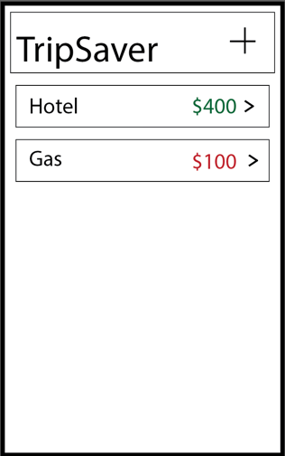 I’m not sure how I’m going to replicate this with android, I realize it’s not going to look as similar as this does to making with apple. I think I need to finish another lab before I can visualize how I’m going to do it. Also, because I’ve already made this app I want to really try to make this app more visually appealing.

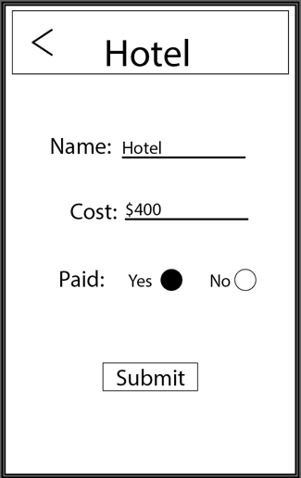 I’m probably going to code something like this:

Public class Item {

String name;

Int cost;

Boolean paid;

public getCost(int itemCost){}

public getPaid(Boolean itemPaid){}

public getName(String itemName){}

public returnCost(){}

public returnPaid(){}

public returnName(){}

}